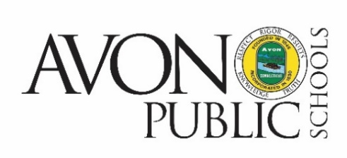

Special Meeting
Avon Board of Education
34 Simsbury Road, Avon, Connecticut
Mission Statement
Our mission is to inspire in each student a joy and passion for learning and a commitment to excellence, personal integrity, and social responsibility.

Tuesday, December 20, 2022, 6:00 pm Avon High School, Library

Avon High School
510 West Avon Road
Avon, CT 06001

Agenda

- Call to order

- Pledge of Allegiance

- Communication from Public
Communications are generally limited to 15 minutes as a total maximum for all speakers, with each speaker limited to
3 minutes in accordance with standing Board policy. The Board may waive these limits in exceptional circumstances.

- Discussion regarding Proposed 2023-2024 Budget

- Adjournment

